Xxxxxxxxxxxxxxxxxxxxxxxxxxxxxx  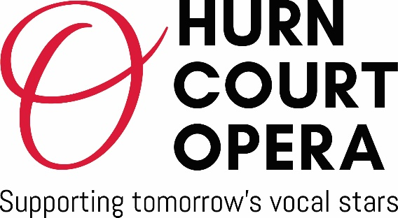  President – Sir Simon Keenlyside CBE  Artistic Director – Lynton Atkinson | Application for  2024 Singer of the Year Competition

Applicant Information
First Name |  |  | Last Name/s |  |  |  |  | Date
Address
City |  |  | County |  |  |  |  | Post code
Contact Phone Number |  |  | E-mail Address
Date of Birth |  | Age on  2nd October 2024 |  |  |  |  | Voice Type

repertoire for Preliminary RECORDED audition

Programme must not exceed 10 mins limit, comprising 2 items – one aria from an opera and one song. Arias must be sung in the original language and key. Songs must be sung in original language but may be in a transposed key. The microphone should be at least 3 metres away and most of the singer’s body should be visible throughout. Live piano accompaniment is preferable, or a recorded piano accomp. may be used. All pieces must be sung off-copy.
ARIA |  | OPERA
COMPOSER |  | MINS.
SONG |  | Song Cycle if any
COMPOSER |  | MINS.

repertoire for SEMI FINALS (IF YOU ARE SELECTED)
on SATURDAY 2nd November 2024
Programme must not exceed 12 mins limit including - at least - 1 aria from opera or oratorio and 2 songs,
each in a different language. If time allows you may add more pieces.
Arias must be sung in the original language and key. Songs must be sung in original language but may be in a transposed key. Only one item from the Preliminary Audition may be repeated, either in the semi-final or in the final
(but not both). Otherwise no repertoire may be repeated. All pieces must be sung off-copy.
Please list in order of performance

SONG or ARIA | SONG CYCLE if any  or OPERA | COMPOSER | Mins

repertoire for FINALS (if you are selected)

on SATURDAY 2nd November 2024
Programme must not exceed 20 mins limit. It may consist of contrasting repertoire chosen by the finalist provided the programme is balanced and contains - at least - two operatic arias and one English song. If time allows you may add more pieces. Only one item from the Preliminary Audition may be repeated, either in the semi-final or in the final (but not both). Otherwise no repertoire may be repeated. Arias must be sung in the original language and key
Songs must be sung in original language but may be in a transposed key. All pieces must be sung off-copy.

Please list in order of performance

SONG or ARIA | SONG CYCLE if any  or OPERA | COMPOSER | Mins

DECLARATION and Signature
The following items have been emailed with my application.
I have included a link to my YouTube audition recordings which were made within
the previous 6 months
I have included a link to my website, or a full biography
My entry fee of £20.00 has been transferred into the designated account of the
HCO Singer of the Year Competition, or paid by bank cheque.
(payment details on next page)

Please confirm where you heard about the HCO Competition
………………………………………………………………………………………………………………………….…………………………………..
- I certify that my answers are true and complete to the best of my knowledge.
- I have read and agree to abide by all the HCO Competition Rules governing this application
and published in the HCO website: www.hurncourtopera.org
- Should I win I agree to perform in at least one of the offered performance opportunities,
subject to availability.
- Should I win I agree to provide the organisers with updates as to my progress and to acknowledge the HCO SINGER OF THE YEAR COMPETITION in all biographical material where possible.
DATA PROTECTION – Contacting you in future
I wish to receive email communications from Hurn Court Opera about future projects – i.e.
workshops, recitals and performance opportunities YES / NO
If you mark this section NO we will delete your personal details after the 2024
competition.
How we will look after the information you put in this form:
We will never give your data to third parties and we will only use it to email you about our events and activities. At any time you can ask to view, update or correct any data we hold on you, and to request that we stop using or erase your data.
Signature |  | Date

PAYMENT DETAILS

tick appropriate box

Payment via internet banking of £20 to the Hurn Court Opera
bank account - Sort Code: 30-96-26 – Account Number: 32283868
If paying via internet banking please include ‘Comp-surname’ (e.g. COMP-SMITH) in the
reference section of the transfer. (If characters in the reference field are limited add the
beginning of your surname.) Please also email kaarina.manzur@hurncourtopera.org to inform
the Administrator that you have paid electronically.

Cheque for £20 made payable to ‘Hurn Court Opera’ and posted to:
Administrator, HCO Singer of the Year Competition
15 Green Close, Woodlands, Southampton SO40 7HU

* Please note that the application fee of £20, and if relevant, the accompanist’s fee for Semi/Finals stage are non-refundable if a singer withdraws from the competition. Payments will be returned if for any reason the application is declined by Hurn Court Opera.

APPLICATION CLOSING DATE – Midnight on 2nd October 2024

Please return completed form and supplementary information
by email to kaarina.manzur@hurncourtopera.org (preferred method)

Contact Number for any queries: 07500 434843
www.hurncourtopera.org
Registered Charity No: 1177609

